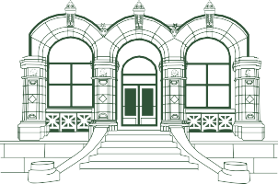



1300 West Park Street | Butte, MT 59701 | 406.496.0000